coal and petroleum

**Natural Resources**: The resources that are obtained from nature are called natural resources, for example, air, water, soil and minerals.

**Inexhaustible Natural Resources**: The resources that are present in unlimited quantities in nature, and cannot be exhausted by human activities, for example, air, sunlight etc.

**Exhaustible Natural Resources**: The resources that are present in limited quantities in nature, and can be exhausted by human activities, for example, coal, petroleum, minerals, forests, natural gas etc.

**Fossil**: The remains of the part of plants or animals transformed over time, is called fossil.

Some exhaustible natural resources from the dead remains of living organisms are known as fossil fuels, for example, coal, petroleum and natural gas.

Coal is a fossil fuel that was formed by the decay of vegetation, which existed millions of years ago. It is a non-crystalline form of carbon.

Fossil (Remains of dead Plants & Animals) + Fuel (Material burnt to produce heat) = Fossil Fuel (Fuel obtained from dead Plants & Animals)

Coal

Coal is a combustible black or brownish-black sedimentary rock with a high amount of carbon and hydrocarbons. Coal is classified as a nonrenewable energy source because it takes millions of years to form. It is a non-crystalline form of carbon. Coal contains the energy stored by plants that iced hundreds of millions of years in swampy forests. It is as hard as stone and is black in colour. Coal is one of the fuels used to cook food. Earlier, it was used in railway engines to produce steam to run the engine. It is also used in thermal power plants to produce electricity. Coal is also used as a fuel in various industries.

About 300 million years ago the earth had dense forests in low lying wetland areas. Due to natural processes, like flooding, these forests got buried under the soil. As more soil deposited over them, they were compressed. The temperature also rose as they sank deeper and deeper. Under high pressure and high temperature, dead plants got slowly converted to coal. As coal contains mainly carbon, the slow process of conversion of dead vegetation into coal is called carbonisation. Since it was formed from the remains of vegetation, coal is also called a fossil fuel.

When heated in air, coal burns and produces mainly carbon dioxide gas.

Coal is processed in industry to get some useful products such as coke, coal tar and coal gas.

**Coal is a versatile fossil fuel that can be transformed into various products through different processes :**

**Electricity** : In Thermal Power Plants, Coal is burned to generate steam, which drives turbines to produce electricity. This is one of the primary uses of coal.

**Coke** : It is a tough, porous and black substance. It is an almost pure form of carbon. Produced by heating coal in the absence of air this process is called destructive distillation. Coke is used in the manufacture of steel.

**Coal Tar** : Coal Tar is a black thick liquid, i.e., a mixture of about 200 substances and is used to get various materials of everyday life/industry, like; synthetic dyes, drugs, explosives, perfumes, plastics, paints, photographic materials, roofing materials, naphthalene balls ,etc. NOTE : These days, bitumen, a petroleum product, is used in place of coal-tar for metalling the roads.

**Coal Gas** : Coal Gas is a by-product that is obtained during the processing of coal to form coke, and is used as a fuel. NOTE : Coal gas was used for street lighting for the first time in London in 1810 and in New York around 1820. Nowadays, it is used as a source of heat rather than light.

Petroleum

You know that petrol is used as a fuel in light automobiles such as motor cycles/ scooters and cars. Heavy motor vehicles like trucks and tractors run on diesel. Petrol and diesel are obtained from a natural resource called petroleum. The word petroleum is derived from petra (rock) and oleum (oil) as it is mined from between the rocks under Earth.

Petroleum was formed from organisms living in the sea. As these organisms died, their bodies settled at the bottom of the sea and got covered with layers of sand and clay. Over millions of years, absence of air, high temperature and high pressure transformed the dead organisms into petroleum and natural gas.

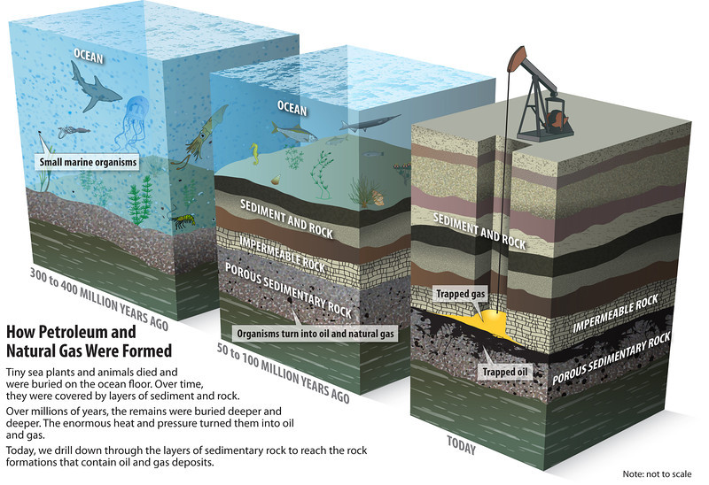

Look at Figure, It shows the deposits of petroleum and natural gas. You see that the layer containing petroleum oil and gas is above that of water. Why is it so? Recall that oil and gas are lighter than water and do not mix with it.

NOTE : The world’s first oil well was drilled in Pennsylvania, USA, in 1859. Eight years later, in 1867, oil was struck at Makum in Assam. In India, oil is found in Assam, Gujarat, Mumbai High and in the river basins of Godavari and Krishna.

Various constituents of petroleum and their uses are as follows:

|  |  |
| --- | --- |
| Constituents of Petroleum | Uses |
| Petroleum Gas in Liquid form (LPG) | Fuel for home and industry |
| Petrol | Motor fuel, aviation fuel, solvent for dry cleaning |
| Kerosene | Fuel for stoves, lamps and for jet aircrafts |
| Diesel | Fuel for heavy motor vehicles, electric generators |
| Lubricating oil | Lubrication |
| Paraffin wax | Ointment, candles, vaseline etc. |
| Bitumen | Paints, road surfacing |

**Refining of Petroleum**

Petroleum is a dark oily liquid. It has an unpleasant odour. It is a mixture of various constituents such as petroleum gas, petrol, diesel, lubricating oil, paraffin wax, etc. The process of separating the various constituents/ fractions of petroleum is known as refining. It is carried out in a petroleum refinery.

Many useful substances are obtained from petroleum and natural gas. These are termed as ‘Petrochemicals’. These are used in the manufacture of detergents, fibres (polyester, nylon, acrylic etc.), polythene and other man-made plastics. Hydrogen gas obtained from natural gas, is used in the production of fertilisers (urea). Due to its great commercial importance, petroleum is also called ‘black gold’.

Natural Gas

Natural gas is a very important fossil fuel because it is easy to transport through pipes. Natural gas is stored under high pressure as compressed natural gas (CNG). CNG is used for power generation. It is now being used as a fuel for transport vehicles because it is less polluting. It is a cleaner fuel. The great advantage of CNG is that it can be used directly for burning in homes and factories where it can be supplied through pipes. Such a network of pipelines exists in Vadodara (Gujarat), some parts of Delhi and other places. Natural gas is also used as a starting material for the manufacture of a number of chemicals and fertilisers. India has vast reserves of natural gas. In our country, natural gas has been found in Tripura, Rajasthan, Maharashtra and in the Krishna Godavari delta.

Conservation of Natural Resources

**Use Energy Efficiently**: Turn Off Lights and Electronics: Switch off lights, computers, and other electronics when not in use.

**Reduce, Reuse, Recycle**:

* Reduce Waste: Minimise waste by consuming less and buying products with minimal packaging.
* Reuse Items: Use items like bags, containers, and clothing more than once.
* Recycle: Recycle paper, plastic, and metal to reduce the need for new materials, which often require fossil fuels to produce.

**Conserve Water**: Repair leaking faucets and toilets to save water. Take shorter showers to use less hot water, which requires energy to heat.

**Use Public Transport**: Use buses or trains instead of driving a car to reduce fuel consumption.

**Walk or Bike**: For short distances, walking or biking is a great way to reduce reliance on fossil fuels.

**Support Renewable Energy**: Understand and promote the use of renewable energy sources like solar, wind, and hydro power.

**Educate Others**: Talk to friends and family about the importance of conserving fossil fuels and ways they can help.

Doubt

Q. Can coal, petroleum and natural gas be prepared in the laboratory from dead organisms?

Answer: while the natural formation of coal, petroleum, and natural gas involves geological processes over millions of years, laboratories can simulate aspects of these processes to produce similar substances. However, producing these resources in significant quantities in the lab is currently not possible or economically viable (successful) compared to natural sources.

Q. Do we use CNG, meaning we use the pure form of natural gas without refining?

CNG is not typically used in its raw, unrefined state. The process to prepare natural gas for use as CNG involves several steps to ensure it meets safety and quality standards:

1. Extraction: Natural gas is extracted from underground reservoirs through drilling.
2. Processing: The extracted natural gas often contains impurities such as water, sulphur compounds, carbon dioxide, and other hydrocarbons (like ethane, propane, butane). Processing involves:
   * Separation: Removing condensates and liquids from the gas.
   * Sweetening: Removing sulphur compounds and carbon dioxide.
   * Dehydration: Removing water vapour to prevent pipeline corrosion and hydrate formation.
3. Compression: Once processed, the natural gas is compressed to high pressures (around 200-250 bar) to reduce its volume and make it suitable for storage and use as CNG.
4. Distribution and Storage: The compressed natural gas is then transported to CNG refuelling stations or directly to industrial and residential users. It is stored in high-pressure cylinders designed for safety and durability.

So, while CNG is derived from natural gas, it undergoes significant processing to remove impurities and ensure it meets quality standards before being compressed for use. This ensures that CNG is clean, safe, and efficient as a fuel source.